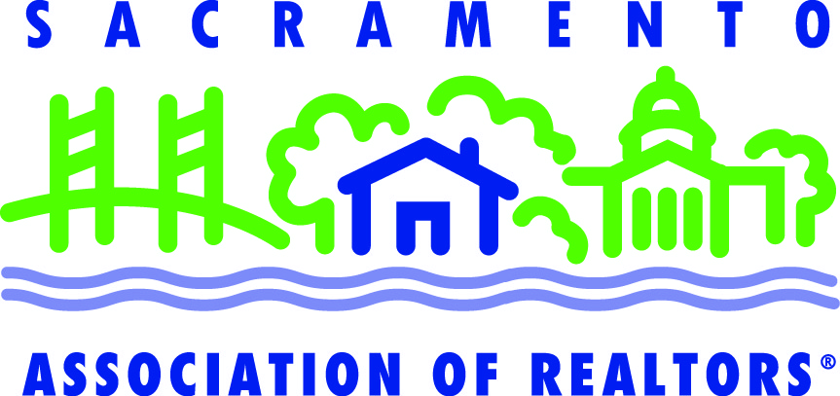 | Internship Sponsor/Mentor Program Application
This Internship Program is a collaboration of efforts between the Los Rios Community College District and the Sacramento Association of REALTORS®. The program has been in place for nearly 20 years, but was on hiatus during the recent economic downturn. It was reinstated in 2013 by SAR’s Internship Committee. Los Rios students who apply for the program must be unlicensed and have successfully passed a class in Real Estate Principles.

As an SAR Sponsor/Mentor you play a critical role. The experience you provide a real estate student will help him/her decide if he/she wants to pursue a career in real estate. For this reason, the SAR Internship Committee has developed several guidelines to which Sponsor/Mentors must adhere. Although you have a significant responsibility for your Intern, those who have served in this capacity in the past have found it quite rewarding.

Please read these before completing this application to ensure you are in a position to serve in a Sponsor/Mentor capacity.
Mentor Information
First name Last name
NRDS Cell phone
Email address
Office Information
Broker office
Office street address
City Zip
Office phone

Have you sponsored an intern in the past? ☐ yes ☐ no

If available, are you interested in sponsoring more than one intern? ☐ yes ☐ no

Why do you wish to sponsor an intern at this time?

What would an intern contribute to your office?

What could you contribute to an intern’s understanding of the real estate industry?

Will you commit to nine hours per week for 16 weeks mentoring an intern? ☐ yes ☐ no

I have read and agree to the Sponsor/Mentor Guidelines and the list of Intern Activities accompanying this application.

_______________________________ _________________________ _______________
Mentor Broker Date

Please return your completed application to Judy Wegener at jwegener@sacrealtor.org or SAR, 2003 Howe Avenue, Sacramento, CA 95825 | 916.437.1207 | fax: 916.779.3945

SAR Sponsor/Mentor Guidelines

The purpose of this internship is to provide hands-on experience in a real estate office for college students who would like to pursue a career in the real estate industry. One reason for this real life experience is that it will help the student determine if he/she is a good fit for this business.
To be eligible to participate in the program a student must have completed a three-unit Real Estate Principles course.
Difference between an Intern Sponsor and an Intern Mentor
For the purposes of the SAR/Los Rios Community College District Internship Program, we have designated Intern Sponsor and Intern Mentor in the following manner.
An Intern Sponsor is a REALTOR® office broker or manager. The sponsor must adhere to the legal requirements listed below, sign the Internship Agreement and ensure that the Intern Mentor is following through with his/her responsibilities. The Intern Sponsor may assign one or more appropriate licensees to serve as the intern’s mentor. The Intern Sponsor may also be the Intern Mentor.
An Intern Mentor may be a REALTOR® office broker, manager or agent. The Mentor is responsible for adhering to the requirements listed below. More will be explained at the Mentor Pre-meeting Session being held prior to Intern interviews on Wednesday, August 14 at SAR.
Intern Mentor Requirements
Since the Mentor is directly responsible for the activities of the intern, we are listing the requirements of the Mentor rather than the Sponsor. The Sponsor, however, must ensure the Mentor is following through with these requirements.
- Your role is to provide your Intern with enough exposure to the business that he/she can decide if it is meant for them. The intern is not to be looked upon as “free labor.”
- Your intern must work in your office for a total of 144 hours – nine hours per week for 16 weeks. He/she will also be attending two-hour biweekly real estate educational sessions at SAR throughout the semester.
- Each Intern will be required to keep a log of his/her internship activities (including time worked) on a daily basis.
- At the conclusion of the internship, both the sponsor and the student will be required to complete a written evaluation. If the internship is satisfactorily completed, the student will receive four units of college credit.
- Every intern will be given the same basic specified training and experience. The training will be as broad and meaningful as possible, while not involving the student in activities that would subject either the intern or the sponsor to liability for unlicensed activities.

- SAR will provide you with a list of activities we would like you to engage your Intern in throughout the 16-week semester. These including taking your Intern to an open house, watching you work on zipForm® and the MLS, preparing marketing materials, etc.
- It should be noted that the internship program is open to full-time and part-time students; however, many of the tasks needed to be accomplished in the program may require availability between the hours of 8:00am and 5:00pm, Monday through Friday.

Sponsor Legal Requirements
- Sponsors must have workers compensation insurance. Please consult your insurance carrier to ensure your insurance covers interns.
- Sponsors must have general liability insurance.
- SAR needs a copy of the broker’s general liability insurance and put SAR as additionally insured. Under CA law, interns will be considered employees.
- You must follow laws against discrimination and you must comply with all applicable federal and state laws regarding discrimination in employment and ADA.
- As a participating Sponsor, you and each mentor must be in good standing with SAR.
- Carefully review the US Department of Labor, Wage and Hour Division Internship Program under the Fair Labor Standards Act.
- If an Intern is going offsite to do a business related activity – someone from the office must drive them.

Activities to be covered by Mentor
This is a list of activities we ask the Mentor to complete with his/her Intern during the 16-week program. More items will be added to this list and provided to you at our Sponsor/Mentor meeting on August 14. Please note that your Intern does not need to learn how to do these activities. They simply need to have exposure to them. If you have any questions, don’t hesitate to call Judy Wegener at 916.437.1207.

- MLS – how to set up a buyer search, create a farm, use a lockbox
- Safety – view NAR Safety video, discuss tools to have on hand for protection
- Appraisal – How to do a CMA, What a BPO is and how to do it
- Forms – Review RPA, Listing Agreement, Zipform, Digital Ink, Counter offers/Addendums
- Escrow & Title – Purpose and role in a transaction, how to review a prelim
- Financing – Different types of loans
- Inspections – Home, pest, chimney, pool, sewer, etc.
- Disclosures – Review of standard disclosures, Agent AVID
- Prospecting – Hosting an open house, what a farm is, creating a database, how to use social media

